Instructions:
- Copy and paste the image and text below into an email
- Add the link to your website where the video is located. Test the link
- Add the recipients email address and press send.

____________________________________________________________________________

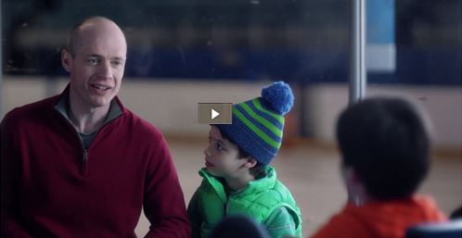

Hi <name>,

I'm excited to share a video, featuring Kurt Browning and his sons with you.

In this video, Kurt talks about the features of a CHIP Reverse Mortgage and how it can help your clients stay in the home they love. This video will be a great way to learn more and it also has Kurt doing a back flip on skates!
To watch the video, click here <insert link to where you uploaded the video>.
Let me know if you have any questions, and we could setup a call or meeting!
Sincerely,
<Your name>
<Your contact information>

<Unsubscribe link>

